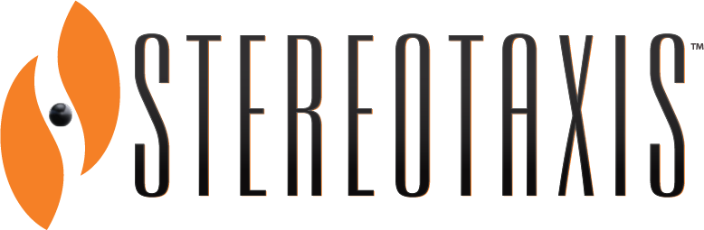

Stereotaxis and Acutus Medical Announce First Integrated Cardiac Ablation Procedure with TeleRobotic Support

St. Louis, MO and Carlsbad, CA, July 31, 2020 (GLOBE NEWSWIRE) – Stereotaxis (NYSE: STXS) and Acutus Medical today announced the first integrated cardiac ablation procedure benefiting from remote TeleRobotic Support. Dr. Gery Tomassoni of Baptist Health in Lexington, KY treated the patient utilizing integrated Stereotaxis Robotic Magnetic Navigation and Acutus AcQMap systems supported by technical and clinical experts from each company using proprietary connectivity technology.

The integrated therapeutic approach combines high-resolution, real-time cardiac imaging and mapping from Acutus' AcQMap system with the precision and stability of Robotic Magnetic Navigation. The integration of these advanced technologies enables physicians to clearly see a patient's arrhythmia pattern and then reach targets to deliver therapy with accuracy.

The TeleRobotic capabilities on the Stereotaxis System provide remote support with real-time diagnostics, preventative troubleshooting, and specialized clinical support during live procedures without the incremental risk or need of having additional personnel in the operating suite.

“In the current and ever-evolving healthcare environment we have to adapt quickly,” says Dr. Tomassoni. “Using TeleRobotics to collaborate with technology experts at Stereotaxis and Acutus has allowed me to maintain my attention on delivering the best therapy to my patients with a network of industry support available on demand.”

AcQMap uses high-resolution ultrasound imaging and charge density mapping to create a clear visual display of the patient's cardiac anatomy and arrhythmia conduction pattern in real time, informing ablation strategy beyond the pulmonary veins. Physicians can then use Stereotaxis Robotic Magnetic Navigation to steer the catheter according to their treatment strategy, allowing for precise guidance in areas of the heart that can be challenging to access. Physicians operate in a control room during the procedure, reducing radiation exposure that can lead to cancer and other health issues.
About Stereotaxis
Stereotaxis is the global leader in innovative robotic technologies designed to enhance the treatment of arrhythmias and perform endovascular procedures. Its mission is the discovery, development and delivery of robotic systems, instruments, and information solutions for the interventional laboratory. These innovations help physicians provide unsurpassed patient care with robotic precision and safety, improved lab efficiency and productivity, and enhanced integration of procedural information. The core components of Stereotaxis’ systems have received regulatory clearance in the United States, European Union, Japan, Canada, China, and elsewhere. For more information, please visit www.stereotaxis.com.
About Acutus Medical
Acutus Medical is an arrhythmia management company focused on improving the way cardiac arrhythmias are diagnosed and treated. Acutus is committed to advancing the field of electrophysiology with a unique array of products and technologies which will enable more physicians to treat more patients more efficiently and effectively. Through internal product development, acquisitions and global partnerships, Acutus has established a global sales presence delivering a comprehensive portfolio of highly differentiated electrophysiology products that provide our customers with a complete solution for catheter-based treatment of cardiac arrhythmias. Founded in 2011, Acutus is based in Carlsbad, California.

This press release includes statements that may constitute “forward-looking” statements, usually containing the words “believe,” “estimate,” “project,” “expect” or similar expressions. Forward-looking statements inherently involve risks and uncertainties that could cause actual results to differ materially from the forward-looking statements. Factors that would cause or contribute to such differences include, but are not limited to, the Company's ability to continue to manage expenses and cash burn rate at sustainable levels, continued acceptance of the Company's products in the marketplace, the effect of global economic conditions on the ability and willingness of customers to purchase its systems and the timing of such purchases, competitive factors, changes resulting from healthcare policy in the United States, including changes in government reimbursement of procedures, dependence upon third-party vendors, timing of regulatory approvals, the impact of the recent coronavirus (COVID-19) pandemic and our response to it, and other risks discussed in the Company's periodic and other filings with the Securities and Exchange Commission. By making these forward-looking statements, the Company undertakes no obligation to update these statements for revisions or changes after the date of this release. There can be no assurance that the Company will recognize revenue related to its purchase orders and other commitments in any particular period or at all because some of these purchase orders and other commitments are subject to contingencies that are outside of the Company's control. In addition, these orders and commitments may be revised, modified, delayed or canceled, either by their express terms, as a result of negotiations, or by overall project changes or delays.
Stereotaxis Contacts:  David L. Fischel  Chairman and Chief Executive Officer  Kimberly Peery  Chief Financial Officer  314-678-6100  investors@stereotaxis.com | Acutus Medical:  Levitate  (260) 408-5383  acutus@levitatenow.com

